Taryn Crawford

Michael Cassens

MART 120

12 September 2021

Mindset Synopsis

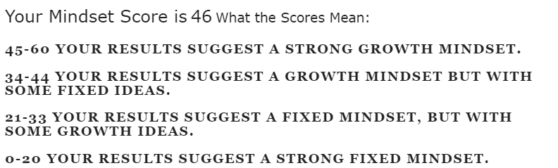 My mindset score is 46. This score means that I have a strong growth mindset. I can see this as being true because I genuinely enjoy learning new things and I am continuously looking for more to learn. When I was younger it was not the case, but when I no longer looked at myself as a failure when I did portly on tests or assignments, I began enjoying the process of learning. I believe that mindset is important, it can help you become more emotionally happy and not give up on something you truly believe in. With the right mindset you can get past the brick walls described in the Last Lecture video. I believe that being mentally aware of mindset can be extremely helpful in making sure that I keep my mind open. It is so easy to get frustrated and want to give up on something, so just reminding yourself how important your mindset is can make a world of difference.